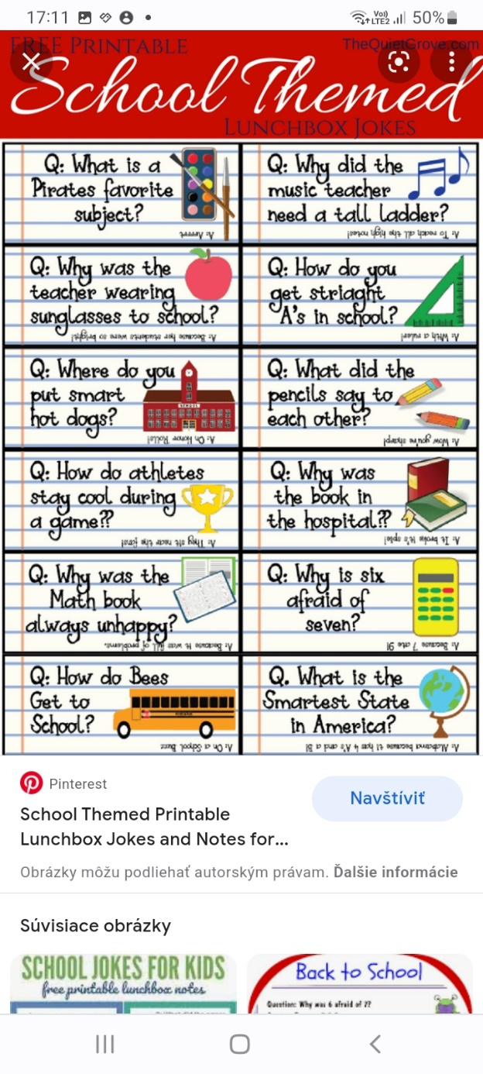 **SCHOOL JOKES**

**Why did**

**the M&M**

**go to school ?**

**He really wanted**

**to be a Smartie !**